Basis of Schedule

Tender for :
Prepared by :
Dated :

Contents
1. Executive Summary
1.1 Client & Project Information 3
1.2 Key Milestones: 3
1.3 Key Assumptions 3
1.4 Key Production Rates 3
1.5 Risks & Opportunities 4
1.6 Summary Program 4
2. Project Summary 5
2.1 Location Map 5
2.2 Scope of Works 5
2.3 Program Overview / Strategy 5
2.4 Project Specific Issues 5
3. Program Details 6
3.1 Location & Identification 6
3.2 General Settings in P6 6
3.3 Work Breakdown Structure 6
3.4 Calendars. 6
3.5 Allowable Working Hours. 6
3.6 Design 6
3.7 Procurement 6
3.8 Construction Methodology 6
4. Key Assumptions 7
4.1 Site Access and Establishments 7
4.2 Productivities 7
5. Overall Labour Histogram 7
6. Critical Path. 8
7. Relevant Project Benchmarking 8
8. Inclement Weather Analysis 8
9. Schedule Risk Analysis 8
10. Contingency 8
Appendix A – Summary Programme 9
Appendix B – Inclement Weather Analysis 9
Appendix C - Schedule Risk Analysis 9
Appendix D – Project Calendars 9
Appendix E – Critical Path 9
Appendix F – Contractual Requirement Relevant to ‘Planning/Programming/Time’ 9
Appendix G - Table of Productivities 9
Appendix H– Schedule Quality Checks 9
Appendix I – Work Breakdown Structure (Level 4) 9

Executive Summary
(note this section to be presented for tender review purposes)

Client & Project Information

Project Name | (input)
Location | (input)
Client | (input)

Key Milestones:
 | Key Dates | Weeks
Tender Submission Date: | (input)
Tender Validity Period: | (input) | (input)
Contract Award: | (input)
Construction Commencement: (Add/Delete as req’d) | (input)
Milestones / Separable Parts Completion:
- Milestone/SP # 1
- Milestone/SP # 2
 |  | Weeks
Contract Date for Practical Completion: | (input) | (input)
Target (Net) Completion Date: | (input) | (input)
SRA P70 Completion Date: | (input) | (input)
Forecast (Gross) Completion Date: | (input) | (input)
Defects Liability Period: | (input) | (input)
 | Percentage
Inclement weather: % of Net | (input) | (input)
Contingency: % of Net | (input) | (input)

Key Assumptions
Site Work Pattern/Roster | (input) Hours/Week | (input) Days/Week
Non Work Days per Annum (RDO's, PH's, Xmas etc) | (input) Days p.a. | (input) weeks p.a.

Key Production Rates
Significant Quantities & Productivities | Total Quantity | Units | Rate Per Day | Crew Size
Activity / Material | (input) | (input) | (input) | (input)
Activity / Material | (input) | (input) | (input) | (input)
Activity / Material | (input) | (input) | (input) | (input)

Risks & Opportunities
ID | Risk / Opport | Description | Proposed Mitigation
7.11 | Risk | (input) | (input)
7.12 | Risk | (input) | (input)
7.14 | Opp | (input) | (input)

Summary Program
(insert high level 1 page program)

Project Summary

Location Map
Insert location map here

Scope of Works
(input)

Program Overview / Strategy
(delivery strategy – workfronts, zones, key drivers, proposed early works)

Project Specific Issues
(input)

Program Details

Location & Identification

Software Requirements
P6 Database
EPS Node
Project Id
Project Name
Data Date
Submission File

General Settings in P6

Default P6 settings are as follows:
Duration Type – Fixed Duration & Units
% Complete Type – Physical
Critical Total Float = 0 hours.

Work Breakdown Structure

Describe how the WBS was developed
Provide Level 4 WBS at Appendix I
Align the WBS with the cost control structure in PCR

Calendars.
The following calendars have been used:

Allowable Working Hours.
Defined in the Project Brief as follows:

Design
Scope and duration
Alignment with design partners
Understanding of client approvals / consent authorities requirements

Procurement
Identify key items of equipment and lead times, crtical path lettings

Construction Methodology
Briefly describe significant methods as highlighted in Item 1.4 above

Key Assumptions

Site Access and Establishments
Site establishmernt layout:

Productivities
See Item 1.4 above for major activities
Add further detail for other activities

Overall Labour Histogram
Refer to the histogram below, displaying anticipated resource requirements
Peak Labour force anticipated to be X JH, Y Subcontractor.

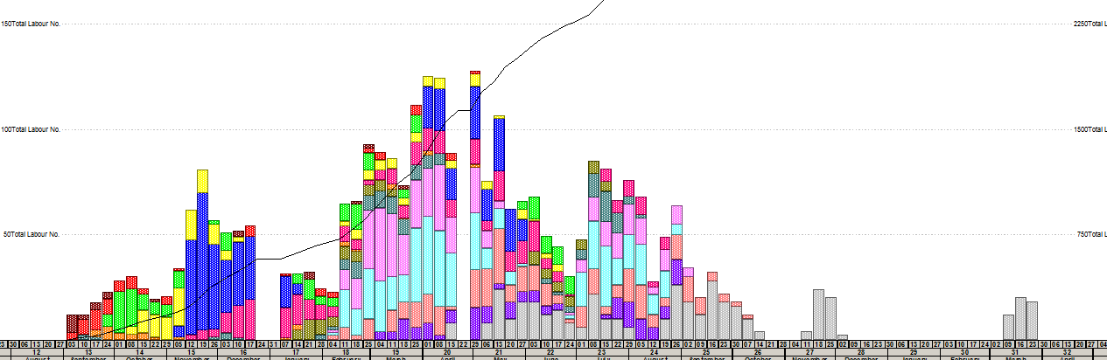

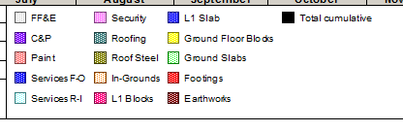
Self-perform manhours in schedule = ??
DJC manhours in estimate = ??

Critical Path.
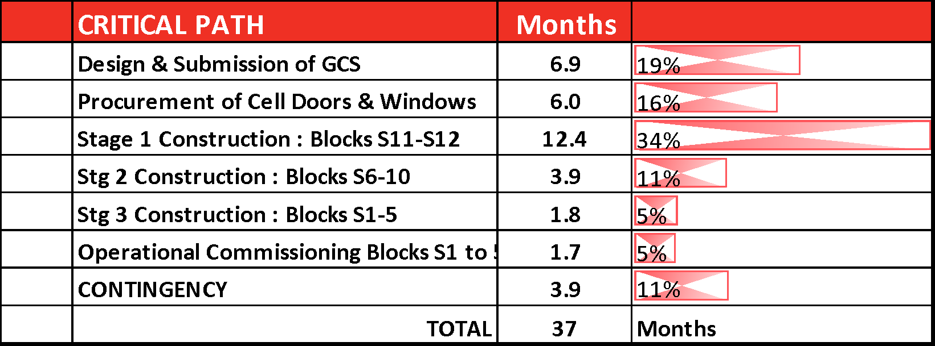

Relevant Project Benchmarking
- Validation that SP’s / Key Dates are achievable from past projects
- Input comparable metric from past similar projects

Inclement Weather Analysis
- Describe methodology

Schedule Risk Analysis
- Describe methodology

Contingency
- See Item in the Exec Summary
- How was this provision calculated?

Appendix A – Summary Programme

Appendix B – Inclement Weather Analysis
(standard insert)

Appendix C - Schedule Risk Analysis
(software outputs)

Appendix D – Project Calendars
XER Toolkit Printouts

Appendix E – Critical Path

Appendix F – Contractual Requirement Relevant to ‘Planning/Programming/Time’

Appendix G - Table of Productivities
(is this required? Already included in the Exec Summary)

Appendix H– Schedule Quality Checks
Provide copy of P6 Schedule Report and XER Toolkit Dashboard
Recommend as a minimum
- List of No Predecessors
- List of No Successors
- Activities with Excessive Total Float
- List of Constraints
- List of Long Duration Activities

Appendix I – Work Breakdown Structure (Level 4)

